Response to development application - A004942635 162 Oceana Terrace, Lota 4179.

INTRODUCTION
Anglicare and Village Retirement Group have failed to come up with an acceptable plan for aged care development at Lota House.
They have ignored the legitimate concerns of local residents who have objected strongly to their proposal.
Their resubmitted application is little changed. If approved, inappropriate high-rise would be built in a low density residential suburb.
Anglicare and Village Retirement Group claim their development plans have been modified to address council and community concerns.
However, Anglicare and Village Retirement Group have:
- only reduced the number of units by 1 - 103 rather than 104
- plans to cut down 55 mature trees - approximately a quarter of the existing woodland
- failed to significantly reduce building heights
- not reduced the total site coverage
- failed to provide a master plan as requested by council
- rejected council’s concerns about the loss of public views to Lota House
- failed to adequately address concerns about the effect high rise would have on the heritage values of Lota House and its adjoining woodland

BACKGROUND
The Applicant seeks approval from Council to establish a Retirement facility, establishing a further 103 independent living units on the site, as well as undertaking Building works on the site of a Heritage place. The proposed 103 dwelling units would take the form of two five storey buildings and two six storey buildings, as well as providing parking spaces within a basement. The existing buildings on the site present as a low-scale, low-density outcome, with heights of generally one to two storeys.
The proposal comprises a significant height, density and bulk that is not anticipated in this locality and is incompatible with the scale of existing development within Lota. The proposal introduces adverse amenity impacts to existing residential uses on Oceana Terrace and Grace Street. The development also diminishes the importance of the heritage building by reducing its prominence from multiple vantage points.
GROUNDS FOR REFUSAL
In summary, the submission expresses the following grounds, and supporting facts and circumstances –
- The compatibility of the proposed building height, bulk and scale within the existing site;
- The appropriateness of the density within the existing site;
- Impacts on the residential amenity; and
- Potential adverse impacts on the amenity values of the Lota House heritage building.

BUILDING HEIGHT, BULK AND SCALE
The site is identified within the Community facilities zone, which does not prescribe a specific building height for new buildings. Instead, the assessment benchmarks of the zone outline that a development is designed to be consistent with the reasonable expectations of the built form of the surrounding land. Performance outcome PO14 and the associated acceptable outcome is reproduced below.
PO14 Development design must be consistent with the reasonable expectations for built form, site layout and landscape design of development on surrounding land.
AO14 Development is of a scale, height and bulk that is not greater than that of surrounding development.
Furthermore, the Overall outcomes for the Community facilities zone code prescribe that development is to be generally consistent with the character of the area and is to provide a sensitive transition to surrounding uses. The overall outcomes of the Community facilities zone code relating to building form are reproduced below:
(4) Development location and uses overall outcomes are:
(i) Development:
(i) is appropriately located according to the type of proposed use;
(ii) is highly accessible and preferably integrated and co-located with complementary uses where possible;
(iii) is of a scale, height and bulk that provides a high level of amenity;
(iv) is generally consistent with the character of the area;
(v) transitions sensitively to surrounding uses.
The above overall outcome is largely duplicated within the Community facilities code.
Considering these requirements are reflected within the three key assessment benchmarks for the development, it is critical that the planning parameters relevant to the surrounding land are taken into consideration when considering what is consistent for the subject site.
Expectations of built form of surrounding land
As shown in Figure 1 below, the location of the proposed development (the southern corner of the site) is predominantly surrounded by land designated within the Low density residential zone. The existing buildings on the site, of one to two storeys, are similarly of a low density and scale. The broader locality, beyond the immediacy of the site, is similarly predominantly within the Low density residential zone and the Character residential zone (i.e. low scale built form outcomes). The overall outcomes in terms of built form for new development within the Low density residential zone is reproduced below (emphasis added):
(1) The purpose of the low density residential zone is to provide for:
(a) a variety of low density dwelling types, including dwelling houses; and
(b) community uses, and small-scale services, facilities and infrastructure, to support local residents.
…
(4) Development location and uses overall outcomes are:
(a) Development provides for suburban living in dwelling houses of predominantly 1 or 2 storeys in height, on appropriately sized and configured vacant lots, which maintain the low density detached housing suburban identity of the Low density residential zone.
…
(d) Development for other housing types, being a residential care facility or retirement facility, which provides housing diversity and enables people to remain within their local neighbourhood throughout their life cycle, may be accommodated at appropriate locations where height is no greater than 1 or 2 storeys.
…
(g) Development reflects and supports the high level of comfort, quiet, privacy and safety (including impacts of glare, odour, light, noise, traffic, parking, servicing and hours of operation) reasonably expected within a predominantly low density permanent residential environment.
…
(5) Development form overall outcomes are:
(a) Development is of a form and scale that reinforces a distinctive subtropical character of low rise, low density buildings set in green landscaped areas.
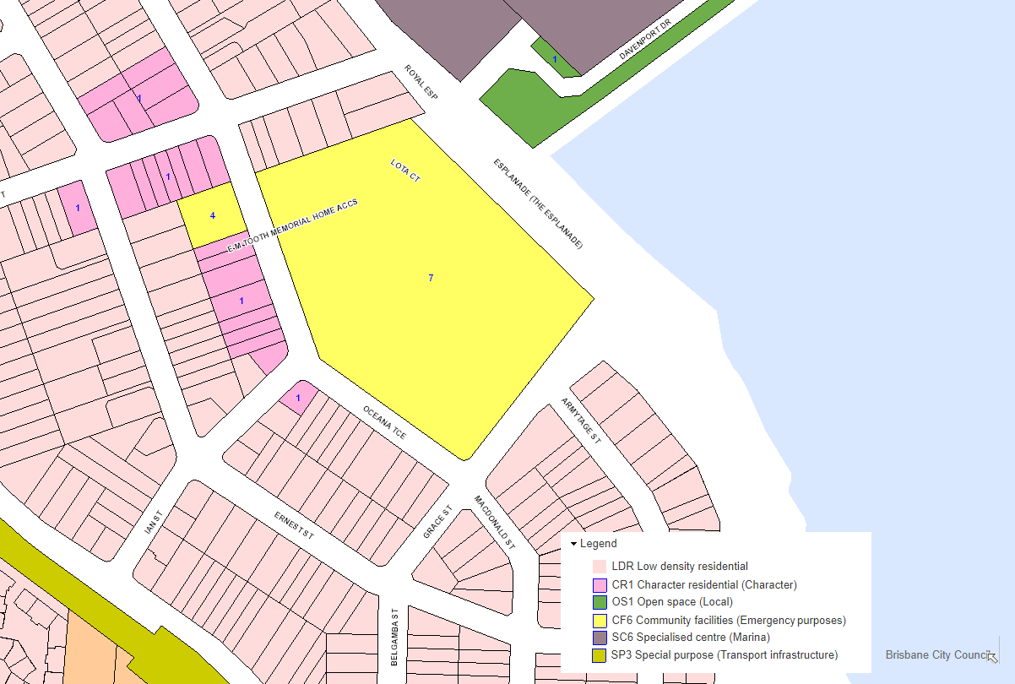
Figure 1: Surrounding zoning of site. The location of the proposed development is within the southern corner of the lot, which is predominantly surrounded by Low density residential properties (source Brisbane City Plan 2014).
Building Height
As shown above, the reasonable expectations of the surrounding land, is repeatedly emphasised by the Low density residential zone as being ‘predominantly 1 or 2 storeys in height’, and of a ‘low density detached housing suburban identity’ while supporting a high level of residential amenity.
A review of the building form of the local area, namely that within the Low density residential zone, reveals the predominant building form being one to two storey detached dwelling houses. Grace Street contains a low set residential care facility. There is no context within the locality for six storey buildings. Indeed, the largest buildings are three storey detached dwellings responding to the steep slopes of Manly. There is no local context for any scale beyond three storeys, where appropriately designed.
In this context, the proposed five/six storeys of the new development are grossly inconsistent with the expectations of built form of the surrounding development, as required by Performance outcome PO14 of the Community facilities code. The development is also grossly inconsistent with overall outcome (4)(i) of the Community facilities code, as the development is not of a scale, height and bulk that provides a high level of amenity (‘amenity’ being defined by City Plan, and including that the development must ensure a high level of light, daylight, breeze and shade, and freedom from hazard or risk – which it is devoid of achieving, to a high level, given the impacts that it creates on the locality). Similarly, the development is grossly inconsistent with overall outcome (4)(i) of the Community facilities code, as the development is not consistent with the character of the area and does not transition sensitively to the surrounding area, as described above.
As a five/six storey height of the buildings fronting onto the street is certainly not consistent with the expectations of the zone.
It is noted that the applicant describes the context of the surrounding area by only providing an analysis of the surrounding land uses, rather than focusing on the surrounding built form. In this way, the applicant has attempted to misdirect Council’s assessment of the context of the locality. The six-storey development is not consistent with, or sensitively transitioning to, the built form or amenity of the one to two storey locality. Accordingly the development is inconsistent with, and creates a high level conflict with, the Community facilities zone code. There are not any relevant matters that would enable the inconsistency to be overcome.
Retirement Living and Aged Care Accommodation Incentives
In response to Performance outcome PO14, the applicant has relied on the Retirement Living and Aged Care Accommodation Incentives (the incentive document) to justify the proposed inconsistency with the reasonable expectations of the locality. The Town Planning Report gives reference to the incentive document but does not provide an assessment against any relevant component, or provide any sense of context.
The development relies on the incentive document to essentially triple the expected building height, yet the incentive document is only mentioned once and then only as a given of its total relevance to this application. Within the Town Planning Report, the Applicant states ‘We believe the changes made to the planning scheme and the approvals issued across the city under the initiative directly alter the expectations of the community in relation to the development of retirement facilities.’
A review of incentive document supporting information reveals the following matters:
- An increase in building height primarily supported for Retirement facilities when located within the Medium density and High density residential zones.
  - The site is not located in either of these zone. In fact, the site is located further than 2 kilometres from the nearest Medium or High density residential zone.
- The document only ever supports an increase of two storeys from the prescribed outcome for these zones.
  - Even if the proposed development were to be located within a Medium or High density residential zone, the proposal would still grossly extend beyond the supported extension by a further three storeys.
- Retirement facilities within the Low density residential zone code are to remain one or two storeys to receive the benefits recommended by the incentive document.
  - In this manner, the incentive document actively seeks to restrict retirement facilities within a Low density residential environment to two storeys and therefore damages the Applicant’s argument about utilising the incentive document for greater height.
- The intent of the incentive document is to grant additional building height to retirement living development where located in zones that the use has a distinct commercial disadvantage to the prevailing use (being multiple dwelling developments). As there is no acceptable outcome for height in the Community facilities zone, it does not benefit from height uplift, and consideration needs to be given to the local context, for which the Low density residential zone is overwhelmingly relevant.
Considering the above matters, I suggest the applicant’s statement that the proposed building height is consistent with ‘expectation of the community’ is grossly inaccurate. The mere existence of the incentive document does not automatically give developers the ability to triple height expectations on all properties within Brisbane, irrespective of context. Context of development, as provided within the Community facilities zone code overall outcomes, is still the critical element of Council’s assessment of any development.
Building Bulk
It is recognised that the subject site affords any development to exceed the predominant building bulk of Oceana Terrace which are generally restricted with 15 metres frontages and areas of 450m². However, the proposed development seeks to provide four buildings at five and six storeys, and individual widths of approximately 43m when viewed from the street.
Additionally, the layout of the buildings will present a combined building width of 84m (scaled from the proposal plans) when viewed from Oceana Terrace. This perspective has been included within the applicant report within Figure 12 of the Town Planning Report.
The applicant has sought to obfuscate the appearance of bulk by greying out Building 2, as if it were to be significantly setback from the road frontage. Furthermore, the bulk of the building is telling in the fact that applicant has not provided proposal plans that show the dimensions of the proposed buildings.
In the context of the surrounding development, the building bulk of the proposal far exceeds anything that is experienced within the locality, and any reasonable expectations of buildings for this site. Retention of some of the existing vegetation is not sufficient to soften the building bulk to an extent reasonable for the surrounding location.
Scale and density
While it is recognised the site is located within the Community facilities zone, Performance outcome PO14 requires development within this zone to be consistent with the reasonable expectations of the surrounding land.
It’s understood the site is already home to 14 independent living units, as well as 64 aged care beds. The proposal seeks to increase this by a further 103 independent living units (this number is very likely to be doubled when the 4 blocks facing the bay will be built at a later stage) thereby resulting in a density of 118 living units and 64 beds. This provides a site density of 1 dwelling unit per 219m² of site area (this number is just for the first 4 blocks).
It is considered that this proposed site density is vastly inconsistent with the expected built form of the locality, which is predominantly comprised of single dwelling houses creating an urban density of approximately 1 dwelling per 400m².
Other Relevant Matters and Need
There is a substantial and high level of inconsistency with the performance outcomes and overall outcomes of the Community facilities zone code. This inconsistency creates conflict with the City Plan, and given that this is a Code Assessment then ‘other relevant matters’ under the Planning Act are not applicable. Notwithstanding, there are not any other relevant matters that overcome such an inconsistency.
Further, the Applicant implicitly and explicitly suggests that there is a need for the development which overcomes any inconsistency with the City Plan. Need in itself is not sufficient in enabling an outcome to this degree of inconsistency with the City Plan, particularly when any need could still be achieved in a lower scale built form. Indeed, the Court of Appeal judgement of Bell v Brisbane City Council QCA 84/2018 is particularly relevant to this point (which applied equally under the Planning Act to the SPA).

Residential Amenity
The above built form considerations will have a detrimental impact on the residential amenity of the surrounding Low density residential zone.
It is anticipated that the proposed density and built form will generate additional traffic movements, noise and loss of privacy to nearby residences to a scale that is inconsistent with the reasonable expectations of the established neighbourhood. By providing the parking spaces within the site, the proposal results in increased vehicle access to the site. The volume of daily traffic anticipated will introduce adverse noise, exhaust and lighting impacts on the residential amenity of the neighbouring residents.
The Applicant has failed to address the residential amenity impacts associated with locating a development of this scale on the doorstep of detached dwellings in a low density residential area. A development of this nature and scale, with the associated vehicle activity, is not reasonably anticipated in the low density residential area.
In direct reference to the assessment benchmarks for this application, the proposed design of the development is not in keeping with Overall outcome (4)(i) of the Community facilities zone code. The proposed scale, height and bulk will significantly impact the high level of amenity that the existing residential properties are accustomed to. Furthermore, the proposal is not consistent with the adjoining residential uses, nor does the design consider the existing character of the Lota area.

IMPACTS TO THE AMENITY VALUES OF THE LOTA HOUSE HERITAGE BUILDING
Lota House is a significant two-storey Queensland Heritage building, constructed in the late 1800s. The design of the proposed development is of an overwhelming scale and bulk, which is not compatible with the colonial style building and its surrounding grounds. In fact, as noted within the Heritage Impact Assessment Report, the vegetation surrounding Lota House was placed under a Vegetation Protection Order at the time of Lota Houses’ inclusion of the Queensland Heritage Register. Furthermore, Lota House is included on the Brisbane City Council Local Heritage Register and it is suggested that Council undertakes a thorough assessment of the impacts to the heritage place, as opposed to deferring assessment to the State Government.
The scale and bulk of the proposed buildings will prevent existing vistas towards Lota House viewed from the public realm. The overall outcomes of the Heritage overlay code in terms of built form for new development on or adjoining a heritage place is reproduced below (emphasis added):
(2) The purpose of the code will be achieved through the following overall outcomes:

- Development on or adjoining a heritage place does not detract from the cultural heritage significance of that heritage place, including any Aboriginal cultural values.
Furthermore, the Performance Outcome PO1 of the Heritage overlay code requires development to provide for the future protection of the heritage place and not to diminish its cultural heritage significance.
The proposal will lessen the significance and prominence of the heritage building and will push the importance of the building’s historical importance from the public’s mind.

OTHER NON-COMPLIANCES
The proposal triggers other areas of non-compliance with the relevant provisions of the Brisbane City as noted below. These, in conjunction with the key issues identified above, warrant refusal of the application.
- The Applicant has not clearly outlined how the proposal will manage the impacts on the amenity of existing residential uses in accordance with Community facilities zone code Overall outcome (5)(c).
- The proposed five and six storey buildings are not consistent with the Wynnum – Manly neighbourhood plan code Overall outcome (3)(a) in retaining and enhancing the unique bayside character, in particular the sense of place and community identity exhibited by the existing built form within Lota and surrounding areas.
- The proposed clearing of HES vegetation and protected vegetation within the site is not consistent with Overall outcome of (3)(d) of the Wynnum-Manly Neighbourhood Plan, which requires the protection of the natural assets of the area.
- Noise assessment is not adequately addressed. In particular, and in accordance with Acceptable outcome AO2.2 of the Community facilities zone code, there are concerns regarding associated rooftop mechanical plant equipment and potential noise generation of approximately 30 residential balconies within close proximity to established houses (keeping in mind that this is only half of what the Applicant is planning to build).

- Performance outcomes PO5 and PO6 of the Multiple dwelling code, which is a secondary code for this application, further reiterates that development is to present a building height and bulk consistent with the existing streetscape and local context. As noted throughout this submission, the proposal does not address these elements sufficiently;
- Overall outcome 2(t) of the Multiple dwelling code requires development to provide design elements that retain and support local character identity. Despite some minor modifications made, the proposal does not include materials or architectural features that reflect the traditional character elements that can be found throughout Lota, but instead presents a domineering and overbearing development entirely divorced from its surrounds.

CONCLUSION
Thank you for the opportunity to make a submission in regards to development application A004942635 over land at 162 Oceana Terrace, Lota. The existing land use provides a critical service by ensuring local residents are able to transition to suitable housing within their existing suburb. It is recognised the planning scheme is written to enable an extension of the existing aged care development where such an extension is compatible with the anticipated character and amenity of the surrounding urban environment.
However, while an extension of the existing development is not objected to in theory, the design of the proposed extension grossly exceeds the community expectation of development within this locality. In this sense, Council must refuse the proposed development on the basis that it is inconsistent with the relevant matters of the planning scheme (namely the Overall outcomes and Performance outcomes of the Community facilities zone code) and even in its re-submitted form this development is not sympathetic with the surrounding neighbourhood.
I would appreciate if Council could take into consideration the grounds of this submission in assessing the application.

